**Week 3 Notes – Soils**

* Soil – earth material (sediment) that has been altered by physical, chemical and biological process such that it can support plants.
* Soil – loose earth material
* Dirt is airborne (dust in your house) ….. Soil is not dirt!

**Soil Formation**

Weathering breaks down rock to sediment. The sediment is then modified to make soil.

Alluvial Soil – soil made from material transported from where the sediment originated…

Colluvial or residual – soil that forms in place from weathered rock.

* Climate
* Topography
* Parent Material (clay, sand etc)
* Organic Processes
* Time

**Soil Organic Matter**

Microorganisms (decompose organic residues and recycle the nutrients)

* Fresh and partly decomposed organic (once living) residue, mostly plants
* Humus – amorphous and without cell structure (manure and compost)
* Typically 1-6% of soil is organic matter
* Soil with 1% or less - deserts
* Soil with 12-18% are organic soils

**Soil Horizons**

O and A – lots of organic material dead plants, worms etc.. Dark color

E – zone of leaching – not shown, poorly drained is yellow and well drained is red (oxidized)

B – Zone of accumulation from above, roots , calcium carbonate (caliche) and clay

C – Altered rock (can be hundreds of feet thick)

R – Bedrock (from here on down its all rock

**Soil Texture**

* Depends on composition and proportion of clay, silt and sand…estimated in the field and confirmed in a lab
* Good for construction:
  + Bedrock – best – hold large loads
  + Gravel – drains and holds a load
  + Sand
  + Silt
  + Clay – worst – doesn’t drain or hold a load

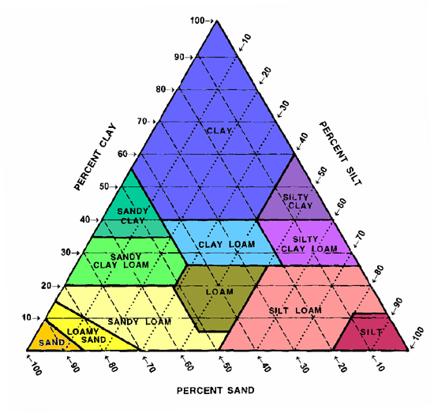

**Soil Fertility**

* Fertility refers to the amount of life in a soil and its ability to supply nutrients (K, N, P)
* Volcanic, floodplain and glacial (mid-west USA) soil are usually fertile. Alluvial soils (desert) are not fertile
* Nutrients added by wind naturally, new volcanic ash and also by man (fertilizer).

**Water Content**

* Porosity – amount of open space or pore space (ability to hold water)
* Permeability – ability to transmit water
* Good soils for agriculture can hold and transmit water
* Good soil for building allows draining and holds a load -

**Engineering Properties of Soil**

* Three phases: solid, liquid and gas
* Particle size and water content
* Plasticity – used to classify materials
  + Liquid limit
  + Plastic limit
  + Liquid limit-plastic limit = plasticity index

PI = 5% could easily flow will added water

PI = 35% could expand by adding water

Loss and gain or resistance to shearing by adding or removing water

* Soil Strength – the ability of a soil to resist deformation.
  + Cohesion – how much the soil particles stick together
  + Friction between grains (you don’t sink in dry sand)
* Clay generally lower strength

**Soil Erosion and Erosion Rates**

* Erosion or transport of soil occurs by water and wind.
* Depends on the type of soil, climate, land use and topography
* US acre is 208 x 208 feet and a hectare is 100 m x 100 m. About 2.5 acres per hectare.
* Rates of erosion measures in kg of soil per year per hectare. Kg/yr/ha
* Erosion occurs by raindrops, sheet flow and rills and gullies.
  + Measure change over time
  + Measure reservoir capacity over a large area.
  + Rate of erosion 10-100 times faster than soil formation
  + Soil in runoff causes pollution of water bodies

**Soil Erosion Equation**

* A - long term soil loss
* R - long term rainfall runoff erosion
* K – soil erodability
* L – hill slope length
* S – hill slope steepness
* C – soil cover
* P – erosion controls
* **A=RKLSCP**

**Where Does the Sediment Go?**

* The rate of reservoir sedimentation depends mainly on the size of a reservoir relative to the amount of sediment flowing into it.
* Capacity in Utah is already down about 15 percent overall, a loss that will nearly double in the next 50 years.
* Large reservoirs in the US lose storage capacity at an average rate of around 0.2 per cent per year. Major reservoirs in China lose capacity at an annual rate of 2.3 per cent.

**Soils, Population Rwanda**

* “Steep hills were being farmed right up to their crests. Even the most elementary measures that could have minimized soil erosion, such as terracing, plowing along contours rather than straight up and down hills, and providing some fallow cover of vegetation rather than leaving fields bare between crops, were not being practiced. As a result, there was much soil erosion, and the rivers carried heavy loads of mud.”
* “One Rwandan wrote me, "Farmers can wake up in the morning and find that their entire field (or at least its topsoil and crops) has been washed away overnight, or that their neighbor's field and rocks have now been washed down to cover their own field." Forest clearance led to drying-up of streams, and more irregular rainfall. By the late 1980s famines began to reappear. In 1989 there were more severe food shortages resulting from a drought, brought on by a combination of regional or global climate change plus local effects of deforestation.”
* Quote from *Collapse* by Jared Diamond

**Land Use**

**Main Changes are Caused by Conversion of Natural Land and Manipulation of Surface water**

* + Deforestation (removes vegetation holding soil in place also less water retention)
  + Urbanization
  + ORVs
  + Desertification

**Industrial Soil Pollution – Point Sources**

Underground gas tanks major polluter

Industrial waste in landfills

Industrial waste storage and spills

Industrial waste water (ponds etc)

Ash and other burn residues

Contaminants cause cancer and health problems

Heavy Metals As, Cd, Cr, Pb, Hg, Zn

Solvents: TCE, PCE, BTEX volatile organics

Burning and semi-volatiles, benzo(a)pyrene, dioxin etc.. PAHs

**Non-Point Source Soil and Water Pollution**

* Can’t trace to one source
* Causes water and soil pollution

**Land Use Surveys**

* Soil, Slope, Surface Water etc., Survey
* Type of soil
* Thickness and extent
* Grain Size
* Moisture Content
* Strength
* Assess Use and Limitations
* None to slight for planned use
* Moderate – overcome with planning
* Severe – Very Careful Controlled Use